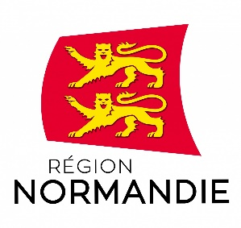 | 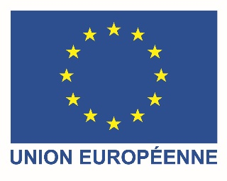

Press release

July 5, 2021

Normandy Region launches a call for applications for international researchers

The Regional Council of Normandy is winner of the last COFUND awards of the H2020 research and innovation programme funded by the European Union. In this framework, Normandy Region launches a call for applications to recruit international post-doctoral researchers in order to host them in Norman research units. 40 experienced researchers will be selected through 2 calls for applications.

The first call of the WINNINGNormandy project opens on July 5th 2021 and the second one will open on July 2022.

“We are glad to have been selected by the European Commission for this large-scale research programme. It will confirm Normandy’s attractivity towards international innovation and research leaders and it will also strengthen mobility between various research sectors. It is a great opportunity for researchers to make their works visible and to develop their career” Normandy President Hervé Morin emphasizes.

Successful applicants will be hosted in the research unit of their choice among the Norman academic institutions. Their project will have to fit in with one or several of the 6 Norman smart specialisation areas for 2021-2027:

- Preserving and sustainably transforming agricultural, marine, forestry and production systems
- Develop an energy mix towards zero carbon emissions
- Transforming processes for a high-performance, sustainable and digital industry
- Develop new low-carbon mobility solutions that are efficient and secure
- Accelerating synergies and innovation in the service of human and animal 5P (Personalized, Preventive, Participative, Predictive and Pluri-expert) medicine
- Make Normandy a resilient territory by mastering technological, natural, health and social risks

Researchers will be financed for 24 months with a €5,540.00/month gross salary and the research and travel costs will be financed as well. Training costs are also included in the budget.

The project will offer experienced researchers an exceptional international, interdisciplinary and intersectoral training program in the identified smart specialisation areas as well as hands-on knowledge in non-research oriented transferable skills necessary for future research leaders.

Applications will be evaluated by international and independent experts on the basis of scientific excellence and career development criteria. Fellows of the programme must not have resided or carried out their main activity (work, studies, etc.) in France for more than 12 months in the three years immediately prior to the call deadline.

The overall budget of this project is €6,96 million including almost €3 million financed by the European Commission.

This project gathers about 40 partners joint together with the Normandy Regional Council. It includes Norman higher education and research institutions and about 20 non-academic institutions.

Only three French regions have been granted a H2020-MSCA-COFUND award since 2014: Normandy, Ile-de-France and Brittany.

https://www.normandie.fr/winningnormandy-fellowship-programme

Information et contact : winning@normandie.fr

Press contact :
Emmanuelle Tirilly – ph : +33 2 31 06 98 85 - emmanuelle.tirilly@normandie.fr

